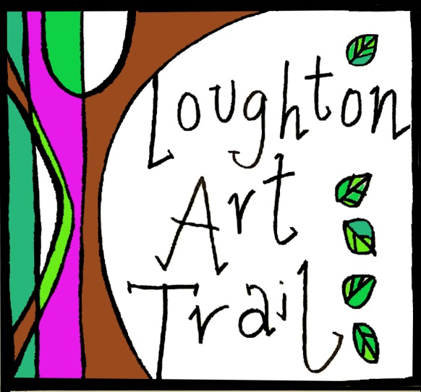

Loughton Art Trail is an annual community arts event that offers engagement with the visual arts to Loughton, Essex, through town-wide arts exhibitions, workshops, talks, walks, and family activities.
Following successful pilot trails in 2014/17, this year’s art trail takes place between 12 May – 2 June 2018. Shops and other businesses, churches and community centres will be displaying artwork by local artists. Loughton Art trail is part of Loughton Festival and the Essex Summer of Art event.
This is an open call for submissions, inviting artists in Loughton and surrounding area interested in exhibiting their work. The event will also include workshops, talks and performances. If you are interested in leading a workshop or talk, please let us know if the comment section. Proposals for performance art are welcome.
Please ensure that you read all details below regarding requirements and submissions. There is no limit on number of submissions, but depending on volume of submissions we may not be able to display all of your pieces. The curators will allocate artwork to certain venues based on suitability for locations, themes and venue needs.
We will be launching our art trail website, www.loughtonarttrail.org, soon. In the meantime please like our facebook page where you can keep in touch with local art events, art trail news and events, artists listing, photos and lots more. https://www.facebook.com/LoughtonArtTrail/

Submission Requirements:
Eligibility: open to all artists living and working in Loughton, Epping Forest and the surrounding area. All mediums will be considered.

Fees, pricing and commissions:
Each piece submitted will require £5 hanging fee. All proceeds will go to the Loughton Art Trail.

Exhibition Requirements:
This call is open to a wide variety of media - painting, drawing, prints, photographs, sculpture, installation etc. However size must be taken into consideration. Proposals for performance work (spoken, musical, etc) are welcome.

Note:
All submissions must be “install-ready” with appropriate hanging devices and/or stands. If appropriate hanging devices are not provided we will not be able to hang your work or provide a refund.
If there are special hanging requirements or your piece is an installation, we strongly recommend you be present during installation.

Submitting:
Please include your name, email, phone number, title of each piece, cash or cheque for hanging fees, and price along with a written description of your work/body of work. We encourage you to send photos along with your submission form.

Website:
We will soon be launching a Loughton Art Trail website. Please indicate if you would NOT like to be included in the website listing with your images, name, description and contact details. (Please put in the comments section)

Please email to loughtonarttrail@gmail.com or send to:

Jenna Thorne, Loughton Methodist Church, 260 High Road, Loughton, Essex, IG10 1RB.

I understand all pricing/fees, exhibition and submission requirements.

Name: ____________________________________

Signature: _________________________________

Date: _____________________________________

Artist Name:

Email:

Phone:

Website/blog address:
Twitter/Instagram handle:
Facebook:
Title of Work/s:

Price/Not for Sale:
Medium:

Description of Work/s:
Dimensions:
Comments:

Would you be happy to volunteer to help at The Art Trail? If yes, please say how.

SUBMISSION FORM

