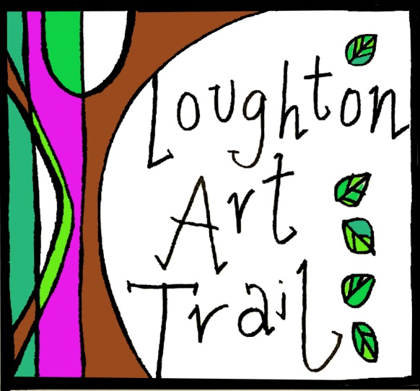

Loughton Art Trail is a bi-annual community arts event that offers engagement with the visual arts to the Loughton, Essex community - through town-wide art exhibitions, workshops, talks, walks, and family activities.
While a climate themed Loughton Art Trail was due to take place from the 15th- 30th of May 2020 as part of a larger climate festival, due the impact of coronavirus the trail has been cancelled.
However, we will now be using the Art Trail website to exhibit and share art by local artists and creatives that not only reflect a climate theme, but also reflect on the current global situation.
This is an open call for submissions, inviting artists and creatives in Loughton and the surrounding area interested in sharing their work. Artwork can reflect the themes in a number of ways through medium (ex: recycled materials), theme, and content. All media are welcome, including proposals for performance art (these can be submitted as videos), poems, short stories, plays and other forms of art.
Please like our facebook page (Loughton Art Trail), instagram (loughtonarttrail) and twitter (@loughtonartrail) to keep in touch.

Submission Requirements:
Eligibility: open to all artists living and working in Loughton, Epping Forest and the surrounding area. All mediums will be considered.

Fees, pricing and commissions:
Exhibiting on the website is completely free.

Submitting:
Please include your name, email, phone number, and title of each piece, along with a written description of your work/body of work. Please ensure you have taken a complete and high quality photograph of work and submit it along with your submission form. Please note, the image you provide will be used on the website. If you are submitting written material, please send it in an attached word document. If your work is in video format, please contact us for further details on how to submit.

Please email to loughtonarttrail@gmail.com

I understand all requirements and that my work will be displayed on the Loughton Art Trail website.

Name: ____________________________________

Signature: _________________________________

Date: _____________________________________

Artist Name:

Email:

Phone:

Website/blog address:
Twitter/Instagram handle:
Facebook:
Title of Work/s:

Medium:

Dimensions:

Price/Not for Sale:
Description of Work/s (blurb to be shared with work on the website):
Comments:

